Things to note before you begin OnStage…
- Maximum 5 team members
- 2m x 2m dance floor for the robots, boundary marked with 50mm black tape
- NOVICE groups (less than 2 years’ experience) can have a roll out mat but it must fit within the boundary (50mm black tape)
- Robot construction and programming is exclusively the students
- Robots are not to be reused robots from previous years
- Costumes are students’ own work
- Music selected is appropriate (no violent or sexual lyrics/sounds)
- Performance goes for longer than ONE minute but no longer than TWO minutes
- As well as the performance, students must participate in an Interview, and complete a Technical Description Paper
- Check the rules and score sheets for complete info here: https://www.robocupjunior.org.au/onstage/

Checklist for each session
Allocate roles for the session
- programmer/s
- robot design and construction
- log book writer and photographer
- robot costume design and construction
- prop design and construction.
This is a robotic competition NOT a costume design competition! Programming the robot comes before costume/prop making.
Complete a logbook entry – including any issues and a photo

Ensure the robot is moving in time to the music or movements compliment the music.

Back up your program file and logbook on a USB

Programmer  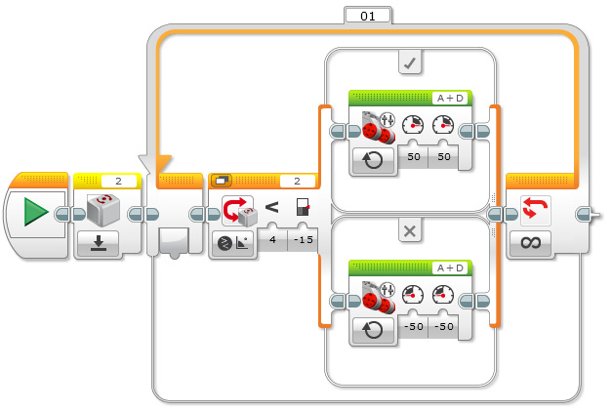 | Robot construction  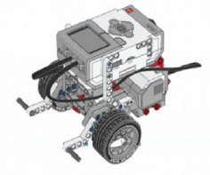 | Log book author/  photographer | Robot costumes | Props construction

Before competition checklist
Practice setting up, performing and packing up within 6 minutes (Who is cueing the music player to start your song? Who is starting the robots? Who brings/takes off on what props?)

Practice for your interview (it’s worth 50% of your mark!)

Complete the Technical Description Paper and submit it online

Fully charge robot and computer

Transfer song onto a USB (the song should be the only data on USB) or upload it online

Pack your audio USB and a backup copy of your song

Pack robots, chargers, computer, computer charger

Pack costume repair kit (scissors, sticky tape, blu tac etc)

Pack spare Lego parts

During performance
- Total performance time limit is 6 minutes (including set up and pack up)
- Robots must perform with the stage floor
- Point deducted for making contact with robot during performance (except when starting robot)
- Request a restart from judges (wait until approval) – a point will be deducted
- Can not restart after 1 minute of performance
- Maximum of 2 restarts

